Statement of Work for Expense Management App Enhancements

Ver: 1.0

Contents

1 Scope 3
2 Architecture 4
3 Technologies Used 5
4 Current Solution 6
5 Proposed Solution 7
5.1 Architecture/Design enhancements 7
5.1.1 Minor Process Adjustments 7
5.1.2 Modular Architecture Refactoring 7
5.1.3 Onboarding of 5 New Subsidiaries 8
5.2 Update/Enhance screen UI 8
5.3 Company Credit card management process 13
5.3.1 Credit Card Expense Management – Requirements 14
6 Timelines 18
7 Point of Contact 19
8 IPR 20

Scope

- Modernize the user interface and add new functionality/workflows to existing expense app.
- Ensure the enhanced UI functions correctly on specified mobile devices (iOS and Android Power Apps mobile application)
- Consistent styling across screens.
- Branding and logos will be as per client guidelines.
- No change to existing functionality
- Existing data sources/connectors remain same.

Architecture

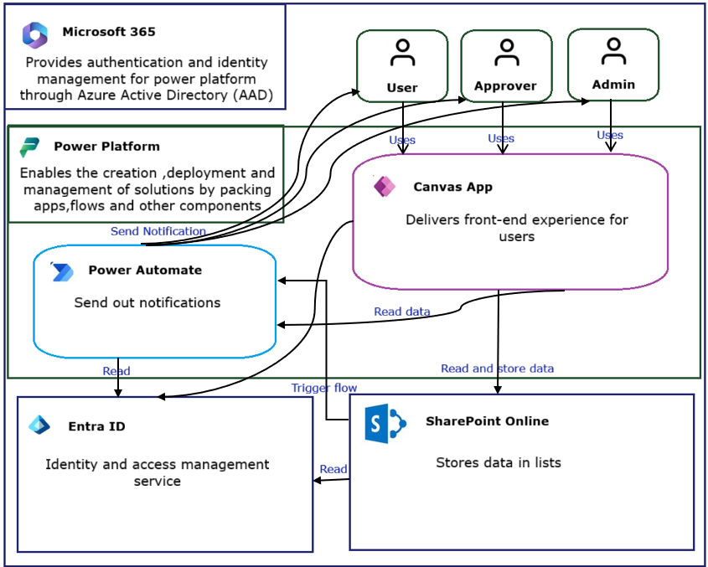

Logical Architecture
- User Interface Layer: Power Apps Canvas App — forms, galleries and other controls.
- Data Layer: SharePoint Online lists.
- Workflow Layer: Power Automate flows for notifications.
- Security Layer: Managed through Azure AD and SharePoint permissions.

Technologies Used

The solution leverages: -

Power Apps (Canvas App) for user interface

SharePoint Online for data persistence

Power Automate for workflow automation

Azure Active Directory (AAD) for authentication and role management

Current Solution

The existing solution is a Microsoft Power Apps Canvas App designed to manage the end-to-end employee expense and BTA (Business Trip Approval) submission and approval process. The app is connected to organizational data sources and enables employees to submit, track, and update expense/BTA requests while allowing managers to review and approve them.

The app is currently operational across the organization but requires enhancements to UI.

Components:

Component | Technology | Description
Frontend App | Power Apps Canvas | Provides interface for employees, approvers and finance team.
Data Storage | SharePoint Lists | Stores expense claims, items, approvals and reference data.
Workflow Engine | Power Automate | Handles notification logic.
Identity Provider | Azure AD | Manages user authentication and role-based access.

Proposed Solution
The proposed solution focuses on providing new functionality and enhancing the UI of the existing Canvas App by implementing reusable functional and design components aligned with Microsoft’s best practices. The goal is to provide a clean, intuitive, responsive, and scalable app that drives higher adoption and operational efficiency.

Key Enhancements in the Proposed Solution

- Make architecture/design enhancements as per section 5.1

- Update/Enhance screen UI as per section 5.2

- Add/implement functionality related to “Company Credit card management process” (more details in section 5.3)

- Apply consistent branding, font styles, icon sets, and color palettes (as it exists in current app).

Deliverables:

Component | Technology | Description
Frontend App | Power Apps Canvas | Solution with updated screens
Data Storage | SharePoint Lists | Same as existing app
Workflow Engine | Power Automate | Same as existing app
Identity Provider | Azure AD | Same as existing app
Technical document |  | Document with details like what is changed, new added screens, business logic etc

Architecture/Design enhancements

Minor Process Adjustments
  - Implement smaller process changes and business rule adjustments provided during the project
  - Example changes include:
    - Conditional field visibility
    - Conditional mandatory fields
    - Field enable/disable logic
    - Process-specific validations

Modular Architecture Refactoring
  - Refactor the existing application into a modular architecture
  - Separate reusable business logic, UI components, and country-specific processes

Onboarding of 5 New Subsidiaries
  - Configure and onboard 5 additional subsidiaries into the existing solution
  - Implement country/subsidiary-specific business rules and processes

Additional Notes
- CLIENT will provide detailed user stories, business requirements, and process specifications
- Vendors are expected to provide:
  - Technical implementation
  - Architecture recommendations
- Solution should be designed with future migration to Dataverse in mind

Update/Enhance screen UI

The look and feel should also be updated for the current systems to give it a better user experience

- Doesn’t match the theme of the app



- Centre the wording
- Colour code the numbers instead of the DOT.
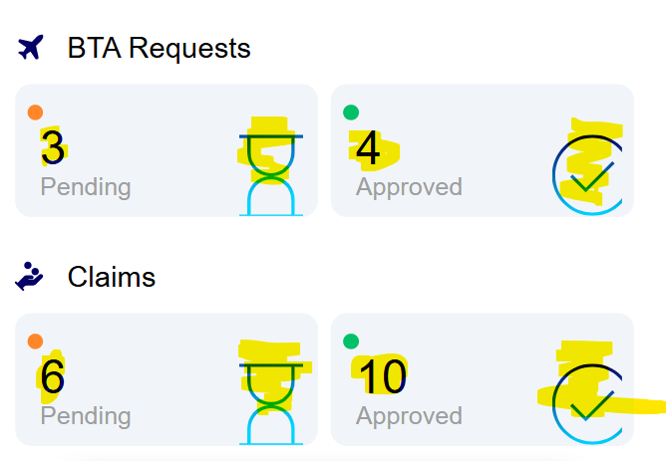

- On the phone this menu is too small. Possible to change from a drop down to a title /tile option

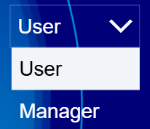

- Remove this space
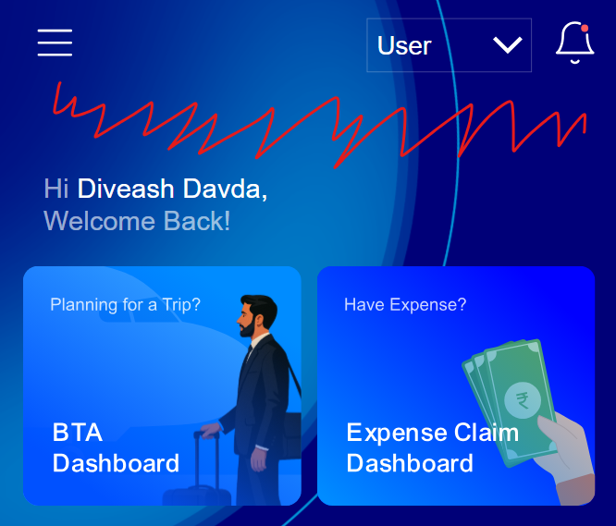

- BTA Screen remove the plus duplicate wording “Create BTA”
- Reduce spacing
- Make the image go to the next screen.


- BTA Request – info not needed
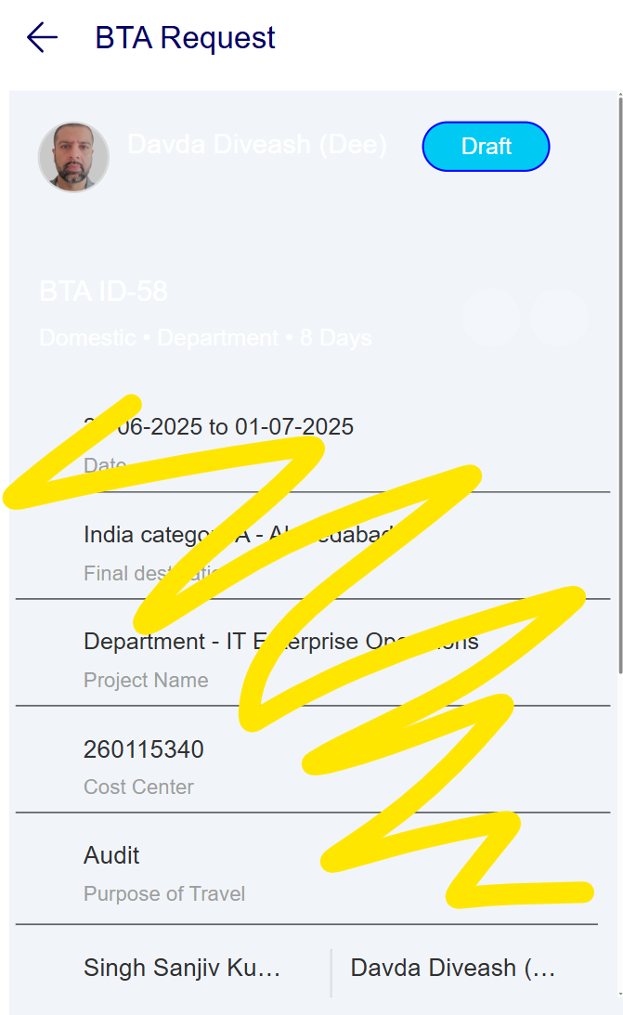

- Waste of screen space (remove


- No edit option for drafts
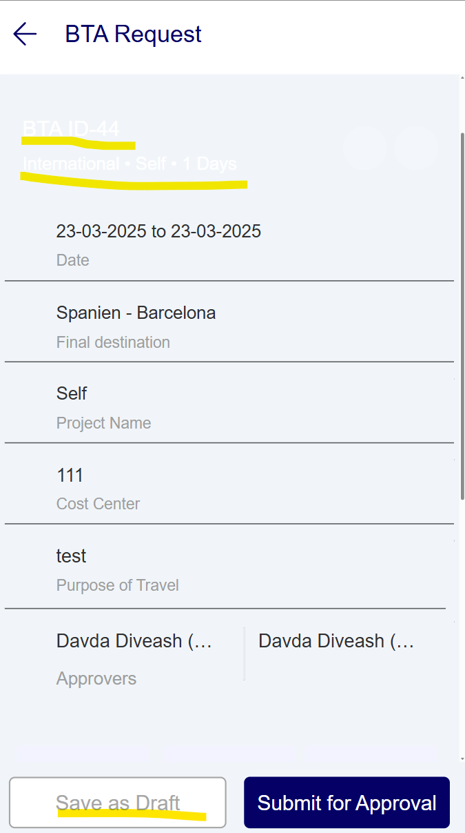

- Empty spaces no edit option
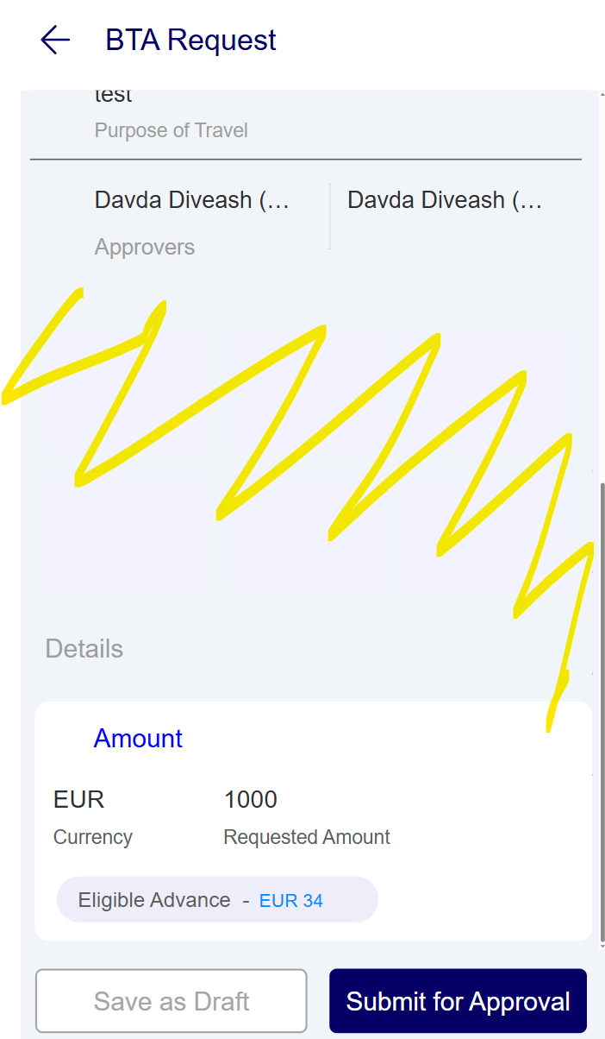

- Missing BTA from bottom menu
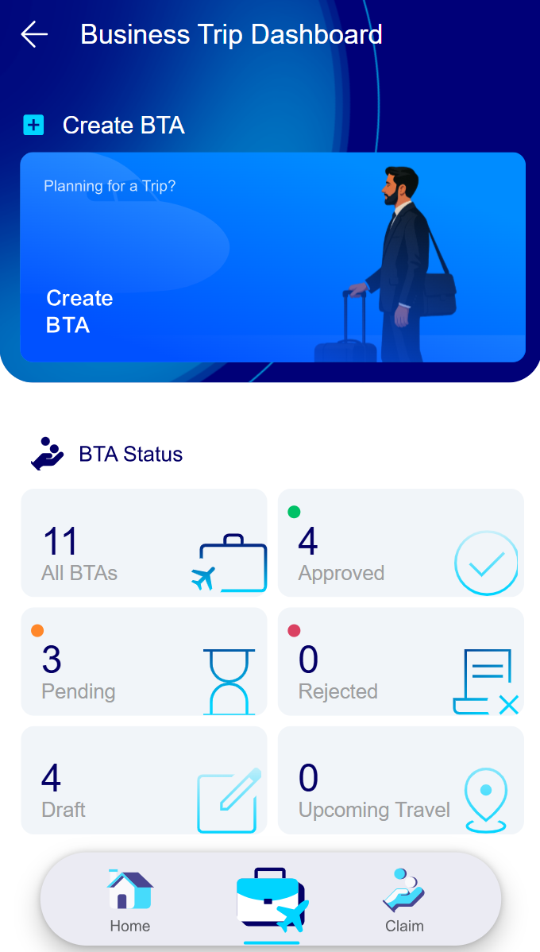

- Remove icon, search needed? Make the pane smaller to fit more on a screen, add edit button ?
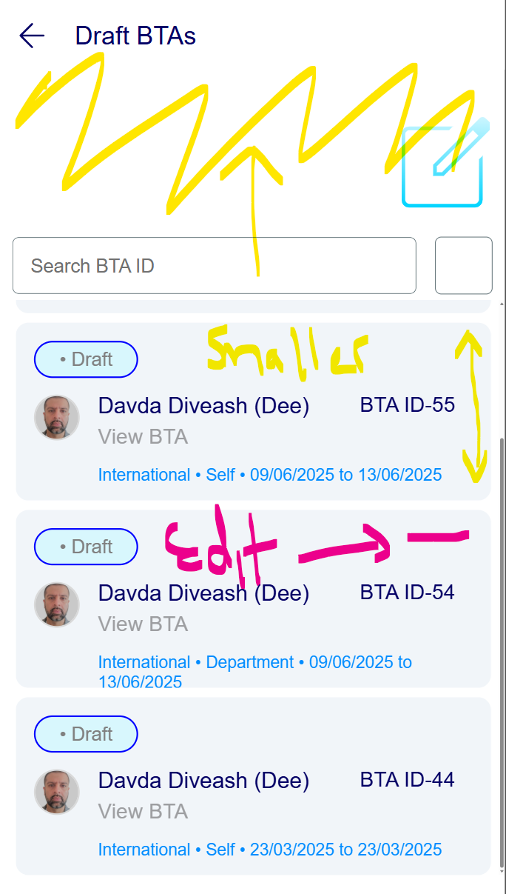

- Expense screen remove section
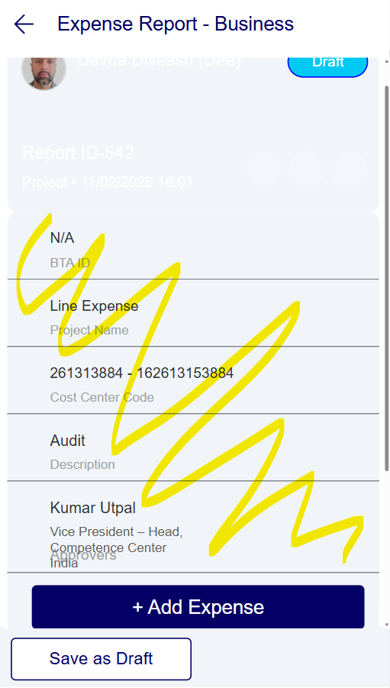

- Move to top
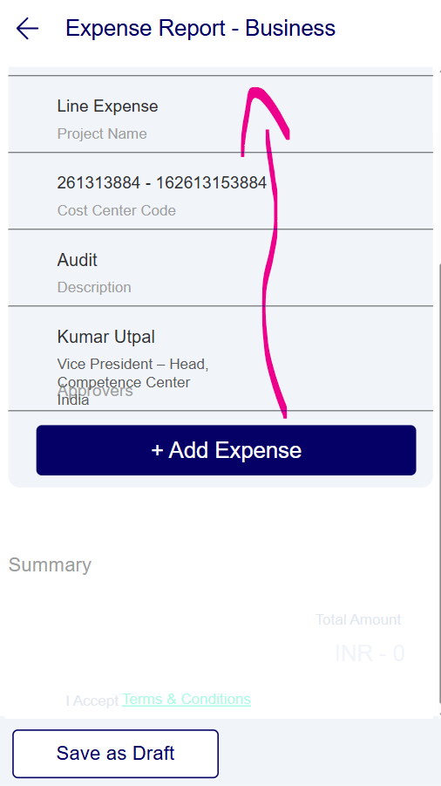
- Missing Star
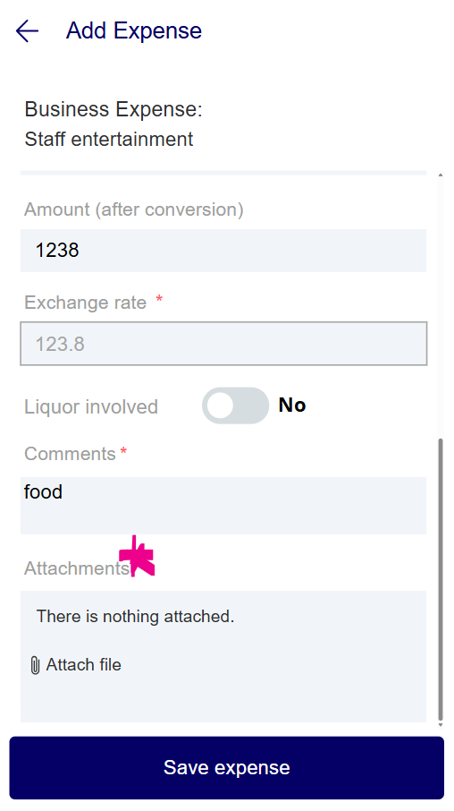

- Make more use of this

- Mention Travel Expenses and Business Expenses - Missing claims from lower menu
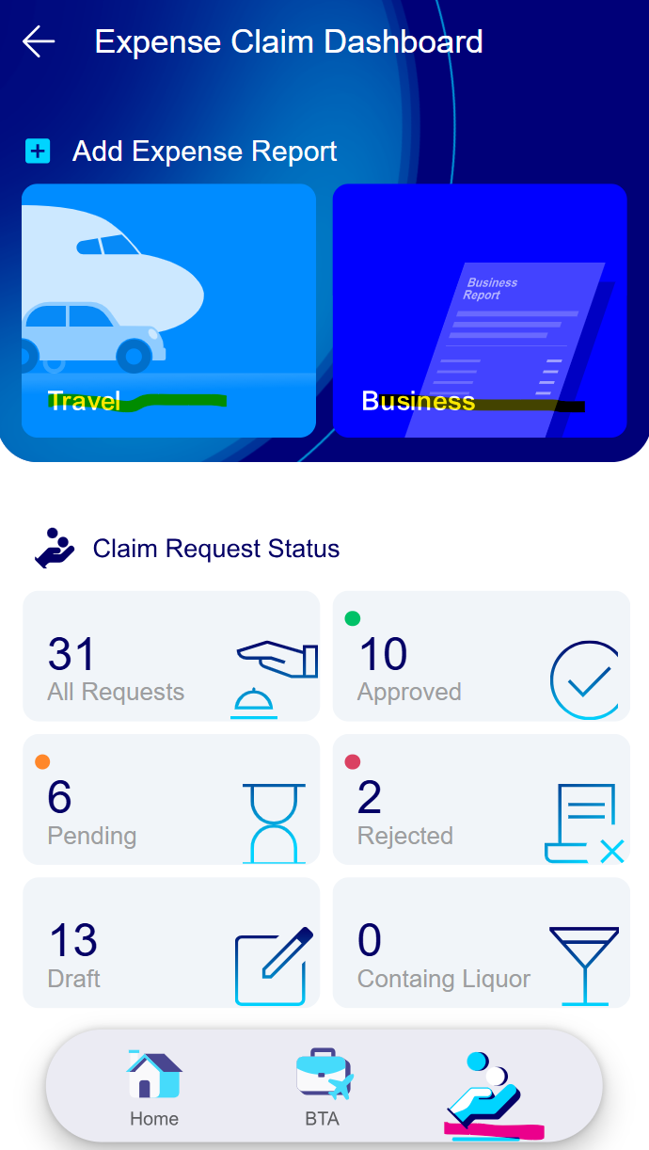

- Add this view to the BTA Edit icon and delete icon Download option is good too , consider email option summary.
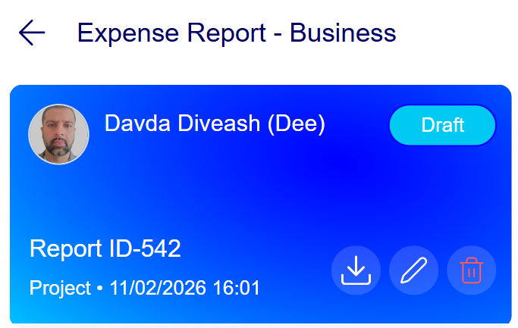

- Remove from expenses
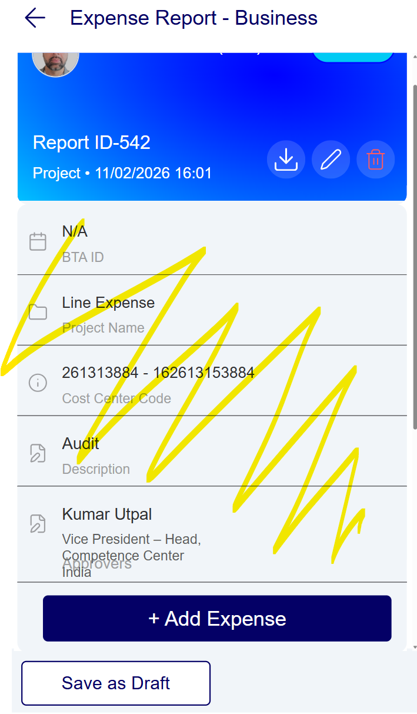

Company Credit card management process

Background:

The Credit Card as issued to the employee and the employees but be apple to log their expenses. Once the credit card statement arrives the finance team should update the information ideally via csv or SharePoint list once all the credit card data is updated employees should get a notification to add all expenses to an expense report for the period specified and the totals should match the finance total no rounding up or down. Once the employee has completed the expense report there should be a functionality to export the report/ and or shave the option to email the summary to an internal email address, copying in the user. When the person replies to the email the user can upload the evidence this is an optional feature that is required a simple radio button is sufficient. Then the employee must accept the T&C and this then sent through to the manager for approval. Then to finance to process and check, the same functionality of the documents viewers are to be used for the approvers. Finance will then process the claim.

Credit Card Expense Management – Requirements

Alignment & Pre-Conditions

- R-01 Alignment with All BU
The solution must align with EP/MS processes for credit card and expense handling.
The system must support CT / MS / EP / VD organisational contexts.

Credit Card Statement Handling

- R-02 Credit Card Statement Arrival
The system must support a process triggered when a credit card statement arrives.

- R-03 Employee ID Mapping
Each credit card transaction must be mapped to an Employee ID.
Mapping must be based on net amount and card reference.

- R-04 CSV Import
Finance must be able to import credit card statements via CSV.

- R-05 CSV Mandatory Fields
The CSV import must support the following mandatory fields:
Employee ID
Credit Card number (last 4 digits only)
Net amount
Statement period (MM/YY)

VAT & Expense Eligibility Rules

- R-06 Local vs International Transactions
The system must identify whether a transaction is Local or International.
Only Local VAT may be claimed.
International VAT must be excluded from VAT reclaim.

Employee Expense Entry

- R-07 Employee Expense Logging
Employees must be able to log expenses against their assigned credit card.

- R-08 Expense Categorisation
Employees must be required to select the correct expense category for each transaction.

- R-09 GL Code Mapping
Each expense category must be mapped to a GL code automatically.

- R-10 Period Assignment
Logged expenses must be saved and added to the correct statement period.

Credit Card vs Expense Reconciliation

- R-11 Net Amount Comparison
The system must calculate:
  - Credit card statement net amount
  - Employee expense report total
The system must compare these values.

- R-12 Exact Match Validation
Submission must only proceed if:
  - CC Report Total = Net Amount
No rounding up or down is allowed.

- R-13 Mismatch Handling
If totals do not match:
  - Employee must provide a reason for net amount mismatch
  - Reason must be stored with the report.

Non-Business Expenses

- R-14 Non-Business Expense Flag
The system must support marking transactions as Non-Business Expense on Credit Card.

- R-15 Non-Business Review
Non-business expenses must be clearly visible during:
  - Manager approval
  - Finance review

Terms & Conditions Acceptance

- R-16 T&C Acceptance
Employee must explicitly accept Terms & Conditions before submission.
Acceptance must be timestamped and auditable.

Functional Manager / Approver Workflow

- R-17 Functional Manager Approval
Expense reports must be routed to the Functional Manager for approval.

- R-18 FYI Notification
An FYI email notification must be sent to the Functional Manager.

- R-19 Hosted Toggle Option
The system must support a toggle option:
  - If hosted approval is enabled → approval happens within the system
  - If not → employee continues to edit/save the report

- R-20 Save & Edit Expense Report
Employees must be able to save and edit expense reports until approval.

Receipts & Evidence Handling

- R-21 Receipt Notification
Employees must receive a notification to attach receipts to the credit card report.

- R-22 Email-Based Receipt Upload
Employees may email receipts to the approver.
The approver must be able to upload receipts from the email.

Manager Approval

- R-23 PDF Generation
The system must generate a PDF version of the expense report for approval.

- R-24 Manager Approval Decision
Managers must be able to Approve or Reject the report.
Decision must be recorded with timestamp and user.

- R-25 Manager Rejection Handling
If rejected:
  - Employee must receive a notification with comments
  - Employee must be able to edit and resubmit the report

Finance Review & Approval

- R-26 Finance Review
Finance must perform a detailed review of the approved report

- R-27 VAT Edit Requirement
Finance must be able to flag “Edit Required – VAT”.
If flagged:
  - Employee must correct VAT data
  - An audit log must be updated

- R-28 Audit Logging
All changes made after Finance review must be logged in the audit trail.

- R-29 Finance Approval
Finance must be able to Approve or Reject the expense report.

Payment & Accounting Integration

- R-30 Payment Processing
Once Finance approves, the system must support Make Payment status.

- R-31 SAP GL Export
For each business there must be a dedicated Excel Export
Approved expense data must be exportable to SAP GL or one will be provided as a template.
Export must include:
  - GL codes
  - Net amounts
  - VAT breakdown
  - Employee ID
  - Etc…. TBD

Credit card management process - status lifecycle
The system must support, at minimum, the following statuses:
- Draft
- Awaiting CC Import
- Reconciliation Required
- Submitted
- Manager Approved / Rejected
- Finance Review
- Finance Approved / Rejected
- Payment Completed
- Exported to SAP GL

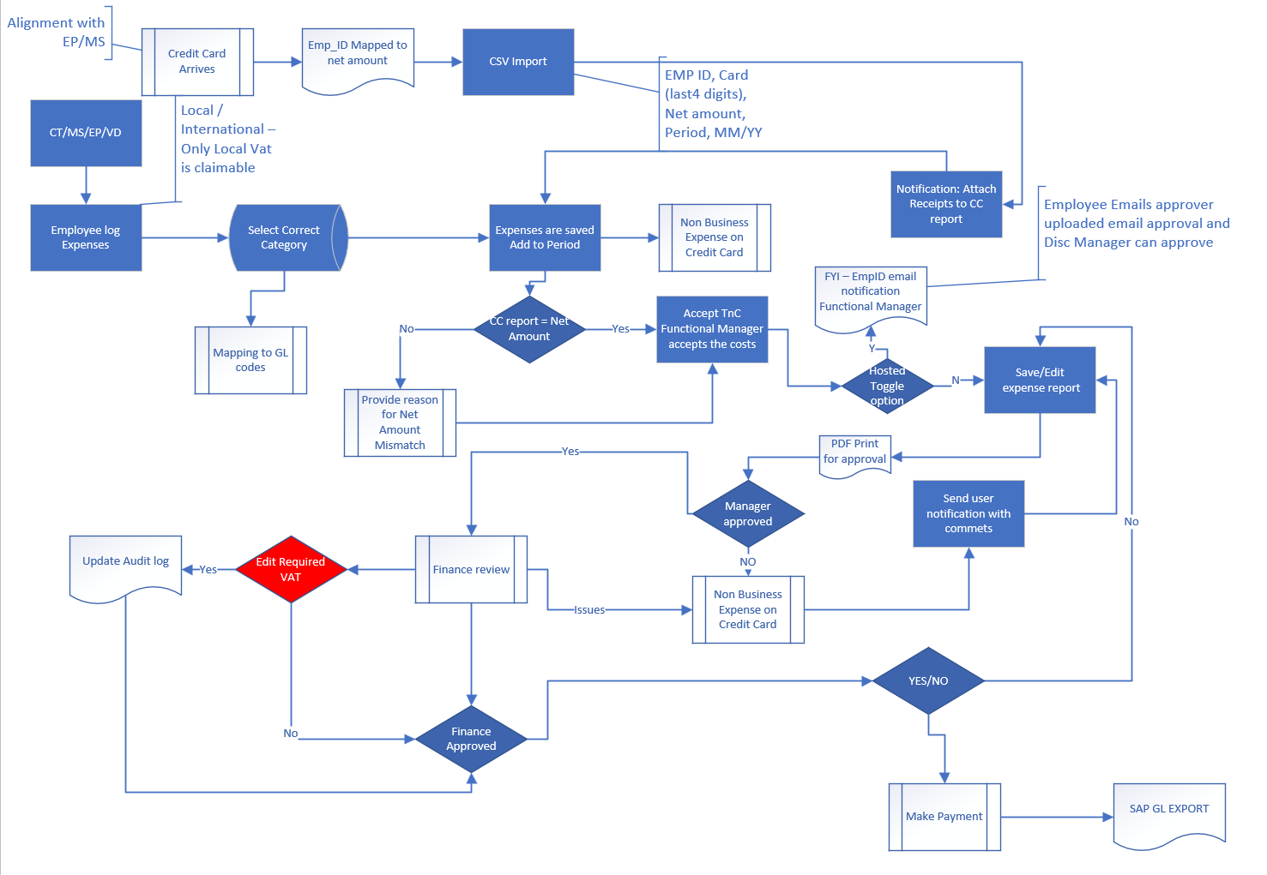

Timelines
- Approx. 3 calendar months to complete all implementation.
- Onboarding and basic KT about the existing solution will be provided by CLIENT.

Point of Contact
For CLIENT India:

IPR
All intellectual property rights in the application, its enhancements, modifications, improvements, etc., created during the engagement shall vest exclusively with CLIENT India. Vendor Infotech shall acquire no rights, title, or interest therein and hereby irrevocably assigns all such rights to CLIENT India, worldwide, in perpetuity. Vendor shall not reuse, reproduce, distribute, or otherwise exploit the work product.

